UNITED STATES

SECURITIES AND EXCHANGE COMMISSION

WASHINGTON, D.C. 20549

FORM 8-K

CURRENT REPORT

Pursuant to Section 13 or 15(d) of the Securities Exchange Act of 1934

Date of Report (Date of earliest event reported): November 07, 2022

DIODES INCORPORATED

(Exact name of Registrant as Specified in Its Charter)

Delaware | 002-25577 | 95-2039518
(State or Other Jurisdiction | (Commission File Number) | (IRS Employer
of Incorporation) |  | Identification No.)
4949 Hedgcoxe Road, Suite 200
Plano, Texas |  | 75024
(Address of Principal Executive Offices) |  | (Zip Code)

Registrant’s Telephone Number, Including Area Code: 972 987-3900

(Former Name or Former Address, if Changed Since Last Report)

Check the appropriate box below if the Form 8-K filing is intended to simultaneously satisfy the filing obligation of the registrant under any of the following provisions:

- Written communications pursuant to Rule 425 under the Securities Act (17 CFR 230.425)

- Soliciting material pursuant to Rule 14a-12 under the Exchange Act (17 CFR 240.14a-12)

- Pre-commencement communications pursuant to Rule 14d-2(b) under the Exchange Act (17 CFR 240.14d-2(b))

- Pre-commencement communications pursuant to Rule 13e-4(c) under the Exchange Act (17 CFR 240.13e-4(c))

Securities registered pursuant to Section 12(b) of the Act:

 |  | Trading
Title of each class |  | Symbol(s) |  | Name of each exchange on which registered
Common Stock, Par Value $0.66 2/3 |  | DIOD |  | The NASDAQ Stock Market LLC

Indicate by check mark whether the registrant is an emerging growth company as defined in Rule 405 of the Securities Act of 1933 (§ 230.405 of this chapter) or Rule 12b-2 of the Securities Exchange Act of 1934 (§ 240.12b-2 of this chapter).

Emerging growth company ☐

If an emerging growth company, indicate by check mark if the registrant has elected not to use the extended transition period for complying with any new or revised financial accounting standards provided pursuant to Section 13(a) of the Exchange Act. ☐

Item 2.02 Results of Operations and Financial Condition.

On November 7, 2022, Diodes Incorporated (the “Company”) issued a press release announcing its third quarter 2022 financial results. A copy of the press release is furnished as Exhibit 99.1.

In the press release, the Company utilizes financial measures and terms not calculated in accordance with generally accepted accounting principles in the United States (“GAAP”) in order to provide investors with an alternative method for assessing the Company’s operating results in a manner that enables investors to more thoroughly evaluate its current performance as compared to past performance. The Company also believes these non-GAAP measures provide investors with a more informed baseline for modeling the Company’s future financial performance. Management uses these non-GAAP measures for the same purpose. The Company believes that investors should have access to the same set of tools that management uses in analyzing results. These non-GAAP measures should be considered in addition to results prepared in accordance with GAAP, but should not be considered a substitute for or superior to GAAP results and may differ from similar measures used by other companies. See Exhibit 99.1 for a description and reconciliation with GAAP of the non-GAAP measures used.

The information furnished in this Item 2.02, including the exhibit incorporated by reference, will not be treated as “filed” for the purposes of Section 18 of the Securities Exchange Act of 1934, as amended (the “Exchange Act”), or otherwise subject to the liabilities of that section. This information will not be deemed incorporated by reference into any filing under the Securities Act of 1933, as amended (the “Securities Act”), or into another filing under the Exchange Act, unless that filing expressly refers to specific information in this Report.

Item 7.01 Regulation FD Disclosure.

The press release furnished in Exhibit 99.1 also provides an update on the Company’s business outlook, that is intended to be within the safe harbor provided by the Private Securities Litigation Reform Act of 1995 (the “Act”) as comprising forward looking statements within the meaning of the Act.

The information furnished in this Item 7.01, including the exhibit incorporated by reference, will not be treated as “filed” for the purposes of Section 18 of the Exchange Act, or otherwise subject to the liabilities of that section. This information will not be deemed incorporated by reference into any filing under the Securities Act, or into another filing under the Exchange Act, unless that filing expressly refers to specific information in this Report.

Item 9.01 Financial Statements and Exhibits.

(d) Exhibits.

 | Exhibit Number |  | Description
 | 99.1 |  | Press release | dated November 7, 2022.
104
 |  |  | Cover Page Interactive Data File (embedded within the Inline XBRL document).

SIGNATURES

Pursuant to the requirements of the Securities Exchange Act of 1934, the registrant has duly caused this report to be signed on its behalf by the undersigned thereunto duly authorized.

DIODES INCORPORATED

Date: November 7, 2022 By: /s/Brett R. Whitmire

Brett R. Whitmire
Chief Financial Officer

Exhibit 99.1
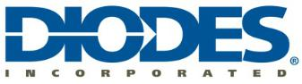

Diodes Incorporated Reports Record Third Quarter Fiscal 2022 Financial Results

Achieves 5th Consecutive Quarter of Record Gross Margin; 7th Consecutive Quarter of Record Adjusted EPS and Revenue

Plano, Texas – November 7, 2022 -- Diodes Incorporated (Diodes) (Nasdaq: DIOD) today reported its financial results for the third quarter ended September 30, 2022.

Third Quarter Highlights

- Revenue was a record $521.3 million, increasing 10.6 percent from $471.4 million in the third quarter 2021 and 4.1 percent from $501.0 million in the second quarter 2022;

- GAAP gross profit was a record $217.8 million, increasing 20.2 percent from $181.2 million in the third quarter 2021 and 5.5 percent from $206.5 million in the second quarter 2022;

- GAAP gross profit margin was a record 41.8 percent, an increase of 340 basis points from the 38.4 percent in the third quarter 2021 and 60 basis points from 41.2 percent in the second quarter 2022;

- GAAP net income was a record $86.4 million, compared to $68.4 million in the third quarter 2021 and $80.2 million in the second quarter 2022;

- Non-GAAP adjusted net income was a record $92.2 million, compared to $67.3 million in the third quarter 2021 and $86.9 million in the second quarter 2022;

- GAAP EPS was a record $1.88 per diluted share, a 25.3 percent improvement from the $1.50 per diluted share in the third quarter 2021 and a 7.4 percent increase compared to $1.75 per diluted share in the second quarter 2022;

- Non-GAAP EPS was a record $2.00 per diluted share, a 36.1 percent improvement from the $1.47 per diluted share in the prior year quarter and a 5.3 percent increase from the $1.90 per diluted share last quarter;

- Excluding $8.1 million, net of tax, of non-cash share-based compensation expense, both GAAP and non-GAAP earnings per share would have increased by $0.18 per diluted share;

- EBITDA was a record $141.9 million, or 27.2 percent of revenue, compared to $114.5 million, or 24.3 percent of revenue, in the third quarter 2021 and $130.6 million, or 26.0 percent of revenue, in the second quarter 2022; and

- Achieved cash flow from operations of $132.2 million and $62.4 million of free cash flow, including $69.8 of capital expenditures. Net cash flow was a positive $78.3 million.

Commenting on the results, Dr. Keh-Shew Lu, Chairman, President and Chief Executive Officer, stated, “Our gross margin and earnings per share continued to expand in the quarter to record levels, driven by another quarter of record revenue combined with outstanding execution by the team, especially considering the COVID-related lockdowns and power outages in certain regions of China for part of the quarter. Contributing to our strong performance was the achievement of record revenue in our automotive and industrial end markets that together totaled 44% of revenue, which is above 41% for the second consecutive quarter and above our 2025 target model. Diodes’ automotive business represented 16% of total revenue for the first time, reflecting the ongoing success of our customer and content expansion initiatives as well as share gains in this end market.

“Over the past several quarters, Diodes has consistently proven its ability to execute amidst one of the most challenging supply chain environments that the industry has experienced and was still able to deliver multiple consecutive quarters of record results, expanded margins and increased profitability. When looking back over the past two years, our revenue has grown 68%, gross margin expanded 590 basis points and adjusted earnings per share increased over 220%. These achievements truly set Diodes apart as a consistent operator through diverse business and economic environments. We are well on our way toward our 2025 financial targets of $2.5 billion in revenue and $1 billion in gross profit.”

Third Quarter 2022

Revenue for third quarter 2022 was a record $521.3 million, increasing 10.6 percent from $471.4 million in the third quarter 2021 and 4.1 percent from $501.0 million in the second quarter 2022.

GAAP gross profit for the third quarter 2022 was a record $217.8 million, or a record 41.8 percent of revenue, increasing from $181.2 million, or 38.4 percent of revenue, in the third quarter of 2021 and $206.5 million, or 41.2 percent of revenue, in the second quarter 2022.

GAAP operating expenses for third quarter 2022 were $105.4 million, or 20.2 percent of revenue, and on a non-GAAP basis were $101.3 million, or 19.4 percent of revenue, which excludes $3.9 million of amortization of acquisition-related intangible asset expenses and $0.1 million of acquisition-related costs. GAAP operating expenses in the third quarter 2021 were $104.0 million, or 22.1 percent of revenue, and in the second quarter 2022 were $100.3 million, or 20.0 percent of revenue.

Third quarter 2022 GAAP net income was a record $86.4 million, or $1.88 per diluted share, compared to GAAP net income in the third quarter 2021 of $68.4 million, or $1.50 per diluted share, and GAAP net income of $80.2 million, or $1.75 per diluted share, in the second quarter 2022.

Third quarter 2022 non-GAAP adjusted net income was a record $ 92.2 million, or $2.00 per diluted share, which excluded, net of tax, $ 3.2 million of acquisition-related intangible asset costs, $2.1 million non-cash mark-to-market adjustment of investments, $0.1 million of acquisition-related costs and a $0.4 million gain on the sale of investments. This compares to non-GAAP adjusted net income of $67.3 million, or $1.47 per diluted share, in the third quarter 2021 and $86.9 million, or $1.90 per diluted share, in the second quarter 2022.

The following is an unaudited summary reconciliation of GAAP net income to non-GAAP adjusted net income and per share data, net of tax (in thousands, except per share data):

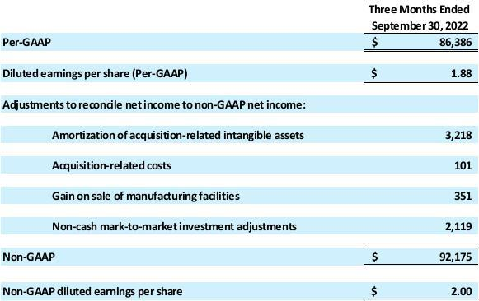

Note: Throughout this release, we refer to “net income attributable to common stockholders” as “net income.”

(See the reconciliation tables of GAAP net income to non-GAAP adjusted net income near the end of this release for further details.)

Included in third quarter 2022 GAAP net income and non-GAAP adjusted net income was approximately $ 8.1 million, net of tax, of non-cash share-based compensation expense. Excluding share-based compensation expense, both GAAP earnings per share (“EPS”) and non-GAAP adjusted EPS would have increased by $0.18 per diluted share for the third quarter 2022, $0.18 for third quarter 2021 and $0.14 for the second quarter 2022.

EBITDA (a non-GAAP measure), which represents earnings before net interest expense, income tax, depreciation and amortization, in third quarter 2022 was a record $141.9 million, or 27.2 percent of revenue, increasing from $114.5 million, or 24.3 percent of revenue, in third quarter 2021 and $130.6 million, or 26.0 percent of revenue, in second quarter 2022. For a reconciliation of GAAP net income to EBITDA, see the table near the end of this release for further details.

For third quarter 2022, net cash provided by operating activities was $132.2 million. Net cash flow was a positive $78.3 million. Free cash flow (a non-GAAP measure) was $62.4 million, which includes $69.8 million of capital expenditures.

Balance Sheet

As of September 30, 2022, the Company had approximately $393 million in cash and cash equivalents, restricted cash, and short-term investments. Total debt (including long-term and short-term) amounted to approximately $296 million and working capital was approximately $765 million.

The results announced today are preliminary and unaudited, as they are subject to the Company finalizing its closing procedures and completion of the quarterly review by its independent registered public accounting firm. As such, these results are subject to revision until the Company files its Form 10-Q for the quarter ending September 30, 2022.

Business Outlook

Dr. Lu concluded, “For the fourth quarter of 2022, we expect revenue to be approximately $494 million, plus or minus 3 percent, in-line with typical seasonality. GAAP gross margin is expected to be 41.0 percent, plus or minus 1 percent. Non-GAAP operating expenses, which are GAAP operating expenses adjusted for amortization of acquisition-related intangible assets, are expected to be approximately 21.0 percent of revenue, plus or minus 1 percent. We expect net interest expense to be approximately $4.0 million. Our income tax rate is expected to be 19.0 percent, plus or minus 3 percent, and shares used to calculate diluted EPS for the fourth quarter are anticipated to be approximately
46.5 million.”

Amortization of acquisition-related intangible assets of $3.2 million, after tax, for previous acquisitions is not included in these non-GAAP estimates.

Conference Call

Diodes will host a conference call on Monday, November 7, 2022, at 4:00 p.m. Central Time (5:00 p.m. Eastern Time) to discuss its second quarter financial results. Investors and analysts may join the conference call by dialing 1-833-634-2590, and international callers may join the teleconference by dialing +1-412-317-6038. A telephone replay of the call will be made available approximately two hours after the call and will remain available until November 14, 2022 at midnight Central Time. The replay number is 1-877-344-7529 with a pass code of 5714382. International callers should dial +1-412-317-0088 and enter the same pass code at the prompt.

Additionally, this conference call will be broadcast live over the Internet and can be accessed by all interested parties on the Investors’ section of Diodes' website at https://investor.diodes.com. To listen to the live call, please go to the investors’ section of Diodes’ website and click on the conference call link at least 15 minutes prior to the start of the call to register, download and install any necessary audio software. For those unable to participate during the live broadcast, a replay will be available shortly after the call on Diodes' website for approximately 90 days.

About Diodes Incorporated

Diodes Incorporated (Nasdaq: DIOD), a Standard and Poor’s SmallCap 600 and Russell 3000 Index company, delivers high-quality semiconductor products to the world’s leading companies in the consumer electronics, computing, communications, industrial, and automotive markets. We leverage our expanded product portfolio of discrete, analog, and mixed-signal products and leading-edge packaging technology to meet customers’ needs. Our broad range of application-specific solutions and solutions-focused sales, coupled with worldwide operations of 32 sites, including engineering, testing, manufacturing, and customer service, enables us to be a premier provider for high-volume, high-growth markets. For more information visit www.Diodes.com

Safe Harbor Statement Under the Private Securities Litigation Reform Act of 1995: Any statements set forth above that are not historical facts are forward-looking statements that involve risks and uncertainties that could cause actual results to differ materially from those in the forward-looking statements. Such statements include statements containing forward-looking words such as “expect,” “anticipate,” “aim,” “estimate,” and variations thereof, including without limitation statements, whether direct or implied, regarding expectations of that for the fourth quarter of 2022, we expect revenue to be approximately $494 million plus or minus 3 percent; we expect GAAP gross margin to be 41.0 percent, plus or minus 1 percent; non-GAAP operating expenses, which are GAAP operating expenses adjusted for amortization of acquisition-related intangible assets, are expected to be approximately 21.0 percent of revenue, plus or minus 1 percent; we expect non-GAAP net interest expense to be approximately $4.0 million; we expect our income tax rate to be 19.0 percent, plus or minus 3 percent; shares used to calculate diluted EPS for the fourth quarter are anticipated to be

approximately 46.5 million. Potential risks and uncertainties include, but are not limited to, such factors as: the risk that the COVID-19 pandemic may continue and have a material adverse effect on customer demand and staffing of our production, sales and administration

facilities; the risk that such expectations may not be met; the risk that the expected benefits of acquisitions may not be realized or that integration of acquired businesses may not continue as rapidly as we anticipate; the risk that the cost, expense, and diversion of management attention associated with the LSC acquisition may be greater than we currently expect; the risk that we may not be able to maintain our current growth strategy or continue to maintain our current performance, costs, and loadings in our manufacturing facilities; the risk that we may not be able to increase our automotive, industrial, or other revenue and market share; risks of domestic and foreign operations, including excessive operating costs, labor shortages, higher tax rates, and our joint venture prospects; the risks of cyclical downturns in the semiconductor industry and of changes in end-market demand or product mix that may affect gross margin or render inventory obsolete; the risk of unfavorable currency exchange rates; the risk that our future outlook or guidance may be incorrect; the risks of global economic weakness or instability in global financial markets; the risks of trade restrictions, tariffs, or embargoes; the risk that the coronavirus outbreak or other similar epidemics may harm our domestic or international business operations to a greater extent than we currently anticipate; the risk of breaches of our information technology systems; and other information, including the “Risk Factors” detailed from time to time in Diodes’ filings with the United States Securities and Exchange Commission.

The Diodes logo is a registered trademark of Diodes Incorporated in the United States and other countries.

Company Contact:

Investor Relations Contact:

Diodes Incorporated

Gurmeet Dhaliwal

Director, IR & Corporate Marketing

P: 408-232-9003

E: Gurmeet_Dhaliwal@diodes.com

Shelton Group

Leanne Sievers

President, Investor Relations

P: 949-224-3874

E: lsievers@sheltongroup.com

DIODES INCORPORATED AND SUBSIDIARIES

CONSOLIDATED CONDENSED STATEMENTS OF OPERATIONS

(unaudited)

(in thousands, except per share data)

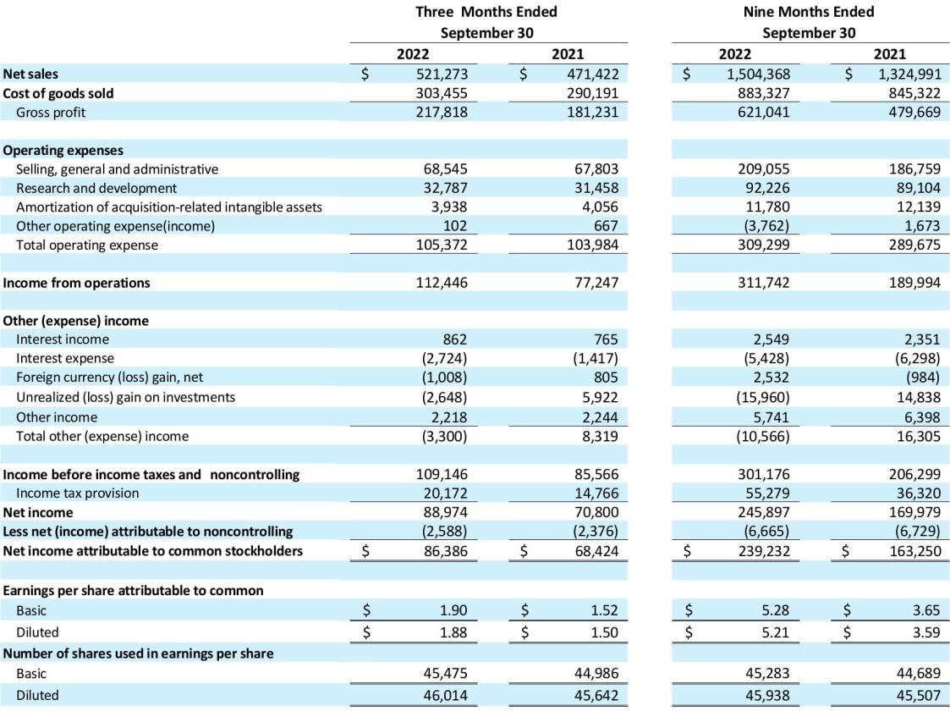

Note: Throughout this release, we refer to “net income attributable to common stockholders” as “net income.”

DIODES INCORPORATED AND SUBSIDIARIES

RECONCILIATION OF NET INCOME TO ADJUSTED NET INCOME

(in thousands, except per share data)
(unaudited)

For the three months ended September 30, 2022:
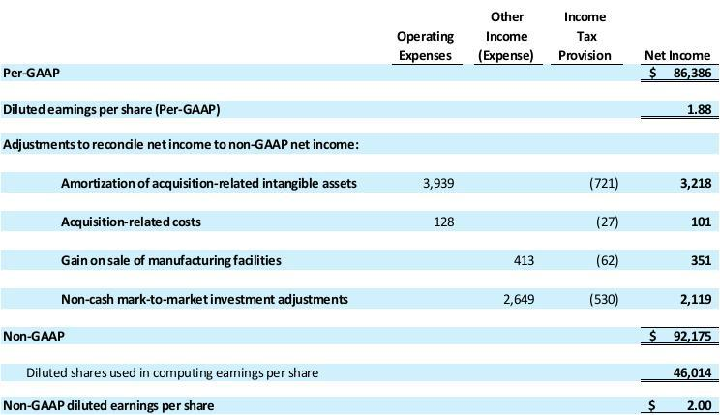

Note: Included in GAAP and non-GAAP net income was approximately $8.1 million, net of tax, non-cash share-based compensation expense. Excluding share-based compensation expense, both GAAP and non-GAAP diluted earnings per share would have improved by $0.18 per share.

DIODES INCORPORATED AND SUBSIDIARIES

CONSOLIDATED RECONCILIATION OF NET INCOME TO ADJUSTED NET INCOME – Cont.

(in thousands, except per share data)
(unaudited)

For the three months ended September 30, 2021:
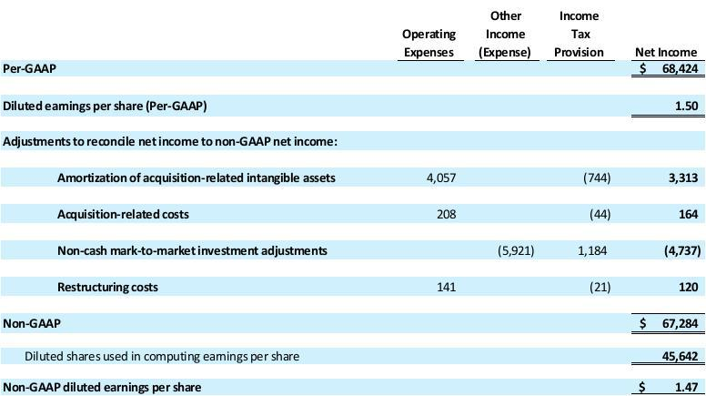

Note: Included in GAAP and non-GAAP adjusted net income was approximately $8.0 million, net of tax, non-cash share-based compensation expense. Excluding share-based compensation expense, both GAAP and non-GAAP adjusted diluted earnings per share would have improved by $0.18 per share.

DIODES INCORPORATED AND SUBSIDIARIES

RECONCILIATION OF NET INCOME TO ADJUSTED NET INCOME

(in thousands, except per share data)
(unaudited)

For the nine months ended September 30, 2022:
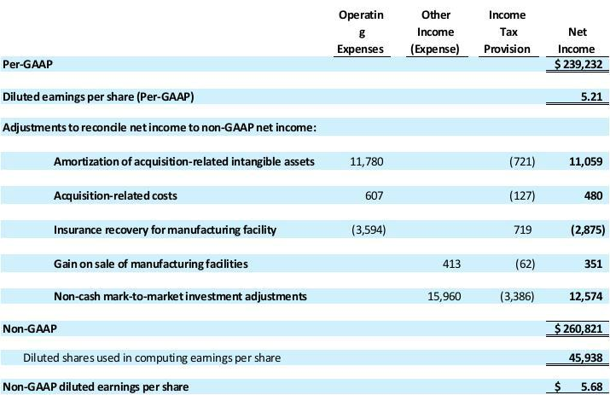

Note: Included in GAAP and non-GAAP adjusted net income was approximately $21.1 million, net of tax, non-cash share-based compensation expense. Excluding share-based compensation expense, both GAAP and non-GAAP adjusted diluted earnings per share would have improved by $0.46 per share.

DIODES INCORPORATED AND SUBSIDIARIES

RECONCILIATION OF NET INCOME TO ADJUSTED NET INCOME

(in thousands, except per share data)
(unaudited)

For the nine months ended September 30, 2021:
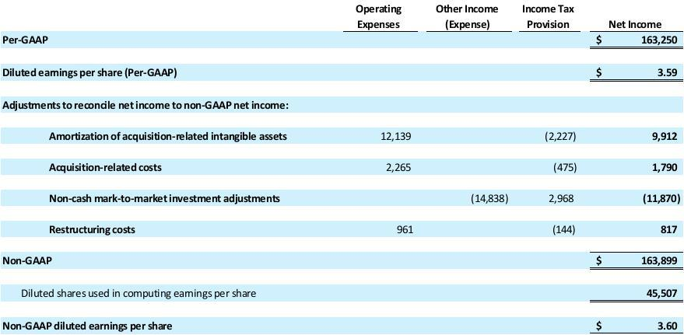

Note: Included in GAAP and non-GAAP adjusted net income was approximately $19.7 million, net of tax, non-cash share-based compensation expense. Excluding share-based compensation expense, both GAAP and non-GAAP adjusted diluted earnings per share would have improved by $0.43 per share.

ADJUSTED NET INCOME AND ADJUSTED EARNINGS PER SHARE

The Company’s financial statements present net income and earnings per share that are calculated using accounting principles generally accepted in the United States (“GAAP”). The Company’s management makes adjustments to the GAAP measures that it feels are necessary to allow investors and other readers of the Company’s financial releases to view the Company’s operating results as viewed by the Company’s management, board of directors and research analysts in the semiconductor industry. These non-GAAP measures are not prepared in accordance with, and should not be considered alternatives or necessarily superior to, GAAP financial data and may be different from non-GAAP measures used by other companies. Because non-GAAP financial measures are not standardized, it may not be possible to compare these financial measures with other companies’ non-GAAP financial measures, even if they have similar names. The explanation of the adjustments made in the table above, are set forth below:

Detail of non-GAAP adjustments

Amortization of acquisition-related intangible assets – The Company excluded this item, including amortization of developed technologies and customer relationships. The fair value of the acquisition-related intangible assets is amortized using straight-line methods which approximate the proportion of future cash flows estimated to be generated each period over the estimated useful life of the applicable assets. The Company believes that exclusion of this item is appropriate because a significant portion of the purchase price for its acquisitions was allocated to the intangible assets that have short lives and exclusion of the amortization expense allows comparisons of operating results that are consistent over time for both the Company’s newly acquired and long-held businesses. In addition, the Company excluded this item because there is significant variability and unpredictability among companies with respect to this expense.

Acquisition related costs – The Company excluded expenses associated with previous acquisitions of that typically consist of advisory, legal and other professional and consulting fees. These costs were expensed as they were incurred and as services were received, and in which the corresponding tax adjustments were made for the non-deductible portions of these expenses. The Company believes the exclusion of the acquisition related costs provides investors with a more accurate reflection of costs likely to be incurred in the absence of an unusual event such as an acquisition and facilitates comparisons with the results of other periods that may not reflect such costs.

Insurance recovery for manufacturing facility – The Company recorded gains related to insurance recovery for a manufacturing facility in Asia. The Company believes the exclusion of the insurance recovery provides investors with a more accurate reflection of the continuing operations of the Company and facilitates comparisons with the results of other periods which may not reflect such gains.

Gain on sale of manufacturing facilities - The Company sold a manufacturing subsidiary and as part of the transaction, there are working capital adjustments that are recorded as gains or losses in the statement of operations. The Company believes this is not reflective of the ongoing operations and exclusion of this provides investors an enhanced view of the Company’s operating results.

Non-cash mark-to-market investment adjustments – The Company excluded market-to-market adjustments on various equity related investments. The Company believes this is not reflective of the ongoing operations and exclusion of this provides investors an enhanced view of the Company’s operating results.

Restructuring costs – The Company recorded restructuring charges related to various international locations. These restructuring charges are excluded from management’s assessment of the Company’s operating performance. The Company believes the exclusion of the restructuring charges provides investors an enhanced view of the cost structure of the Company’s operations and facilitates comparisons with the results of other periods that may not reflect such charges or may reflect different levels of such charges.

CASH FLOW ITEMS

Free cash flow (FCF) (Non-GAAP)

FCF for the third quarter of 2022 is a non-GAAP financial measure, which is calculated by subtracting capital expenditures from cash flow from operations. For the third quarter of 2022, FCF was $62.4 million, which represents the cash and cash equivalents that we are able to generate after taking into account cash outlays required to maintain or expand property, plant and equipment. FCF is important because it allows us to pursue opportunities to develop new products, make acquisitions and reduce debt.

CONSOLIDATED RECONCILIATION OF NET INCOME TO EBITDA

EBITDA represents earnings before net interest expense, income tax provision, depreciation and amortization. Management believes EBITDA is useful to investors because it is frequently used by securities analysts, investors and other interested parties, such as financial institutions in extending credit, in evaluating companies in our industry and provides further clarity on our profitability. In addition, management uses EBITDA, along with other GAAP and non-GAAP measures, in evaluating our operating performance compared to that of other companies in our industry. The calculation of EBITDA generally eliminates the effects of financing, operating in different income tax jurisdictions, and accounting effects of capital spending, including the impact of our asset base, which can differ depending on the book value of assets and the accounting methods used to compute depreciation and amortization expense. EBITDA is not a recognized measurement under GAAP, and when analyzing our operating performance, investors should use EBITDA in addition to, and not as an alternative for, income from operations and net income, each as determined in accordance with GAAP. Because not all companies use identical calculations, our presentation of EBITDA may not be comparable to similarly titled measures used by other companies. For example, our EBITDA takes into account all net interest expense, income tax provision, depreciation and amortization without taking into account any amounts attributable to noncontrolling interest. Furthermore, EBITDA is not intended to be a measure of free cash flow for management’s discretionary use, as it does not consider certain cash requirements such as tax and debt service payments.

The following table provides a reconciliation of net income to EBITDA (in thousands, unaudited):
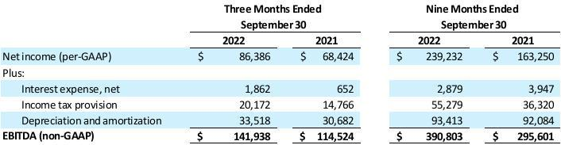

DIODES INCORPORATED AND SUBSIDIARIES

CONSOLIDATED CONDENSED BALANCE SHEETS

(in thousands)


